Appendix A 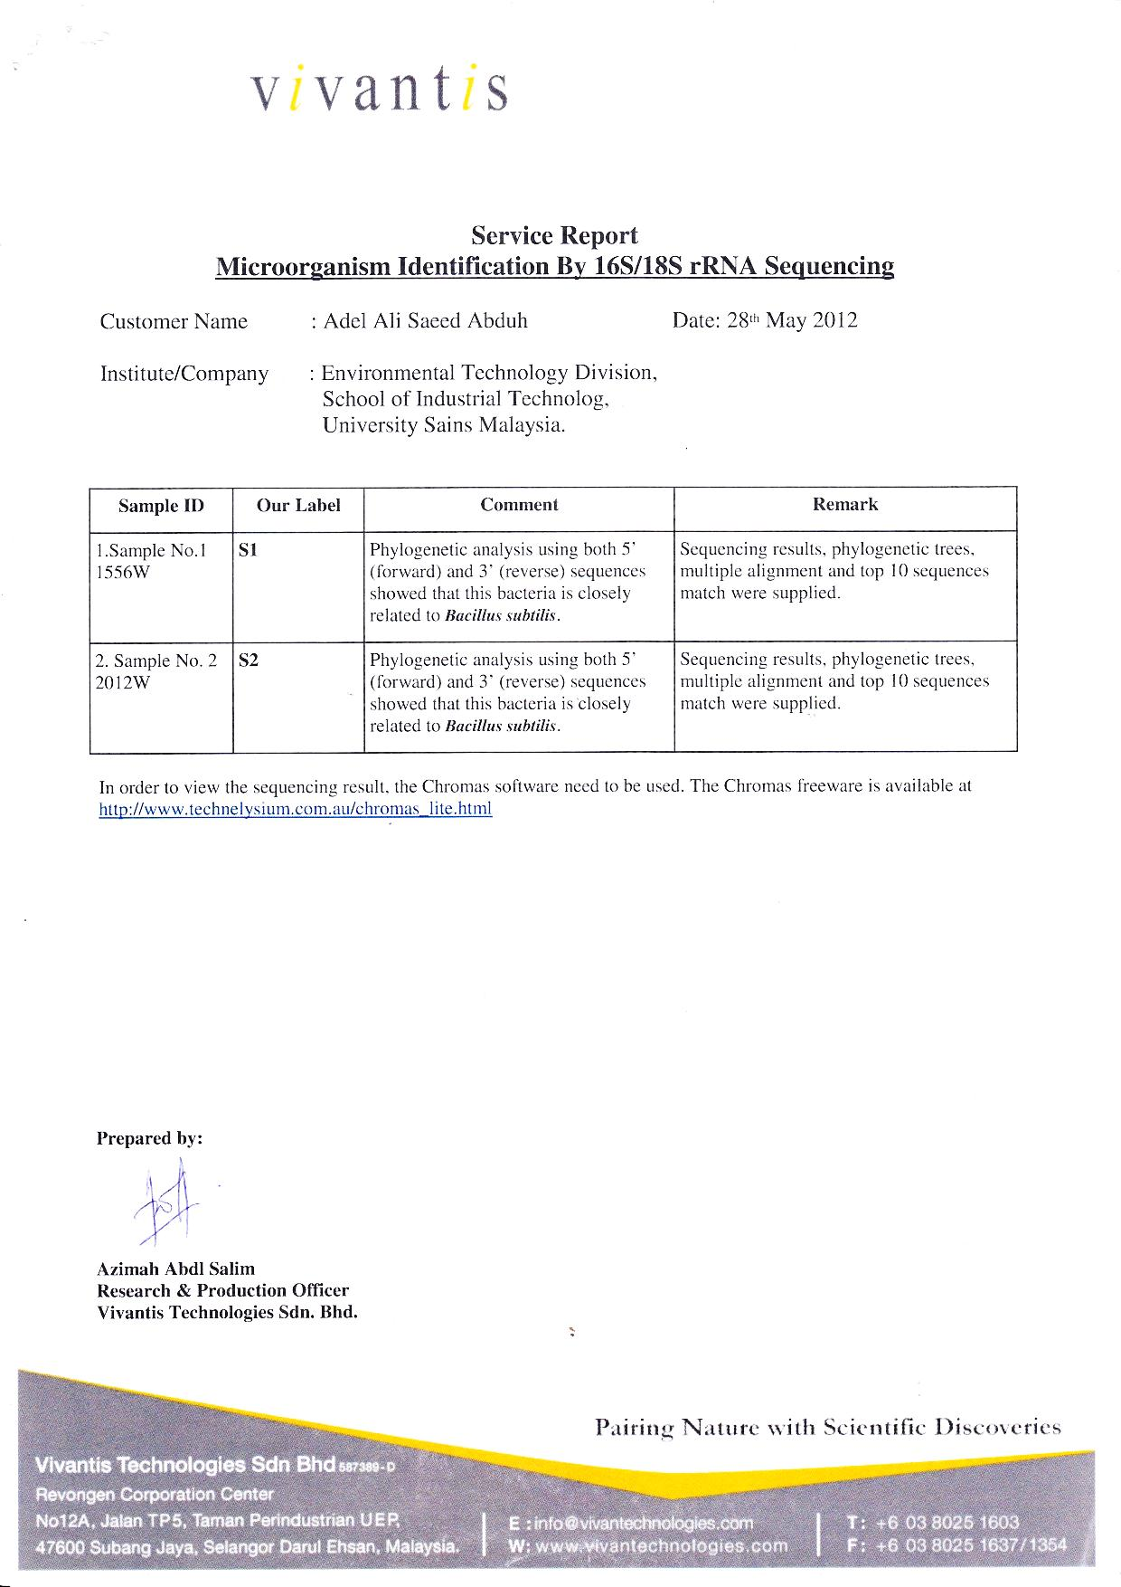

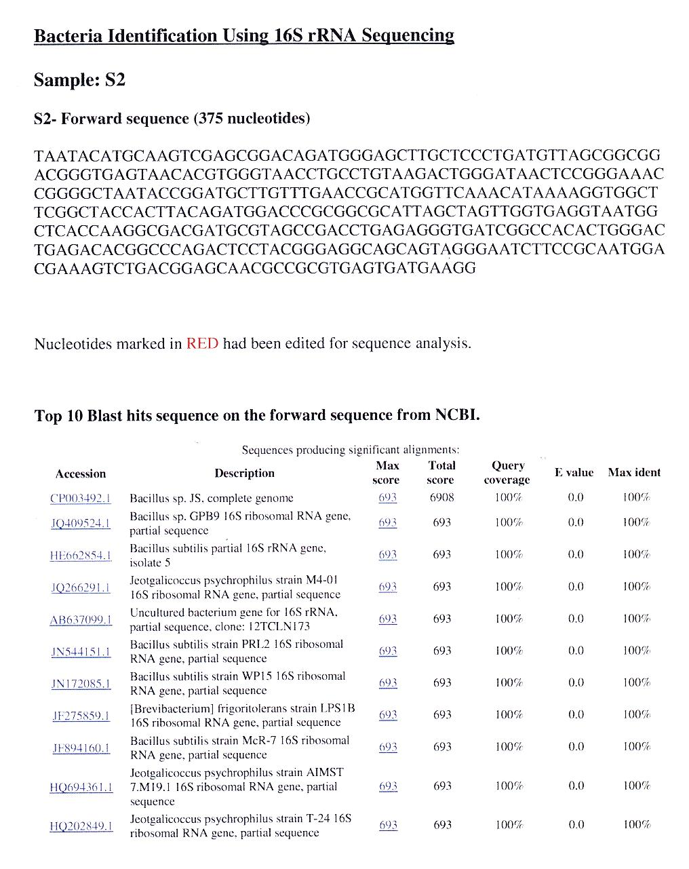

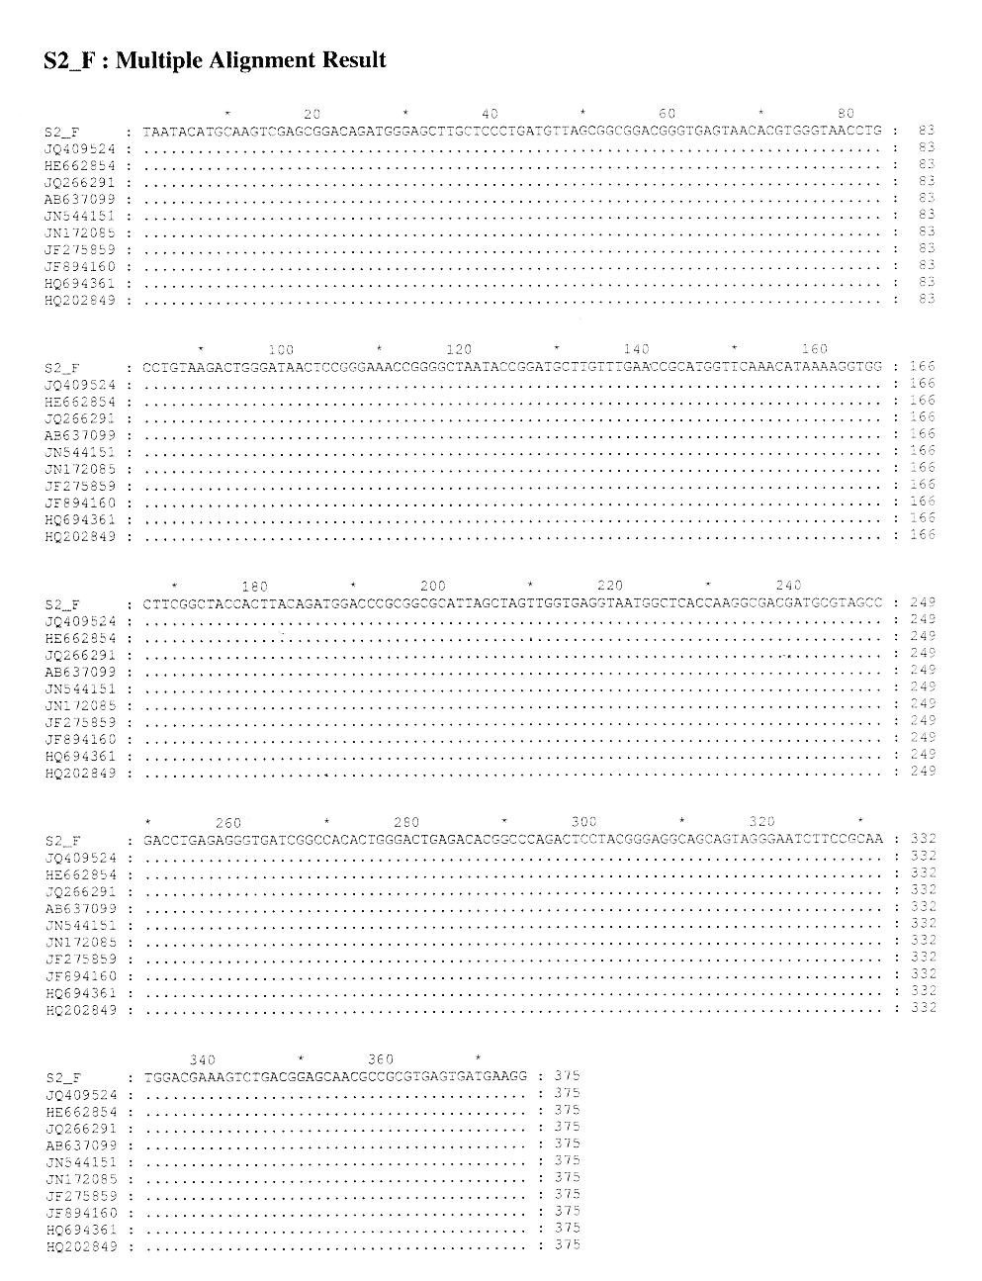
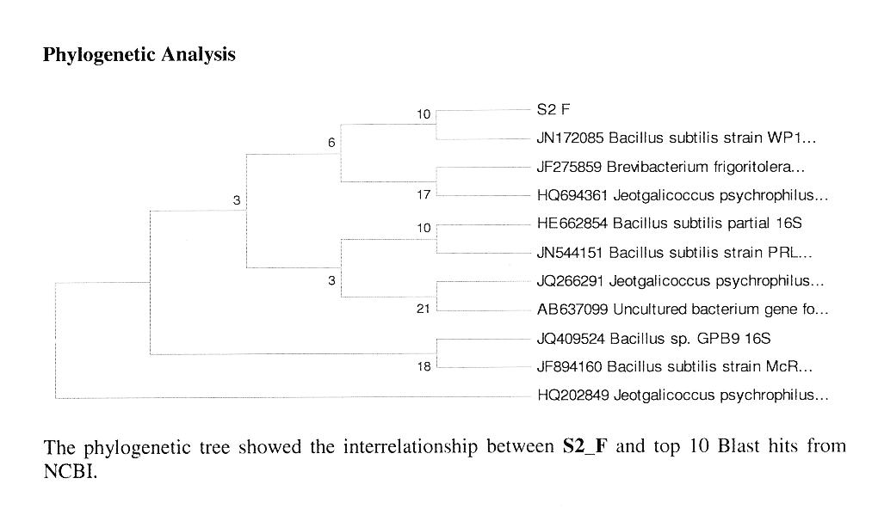

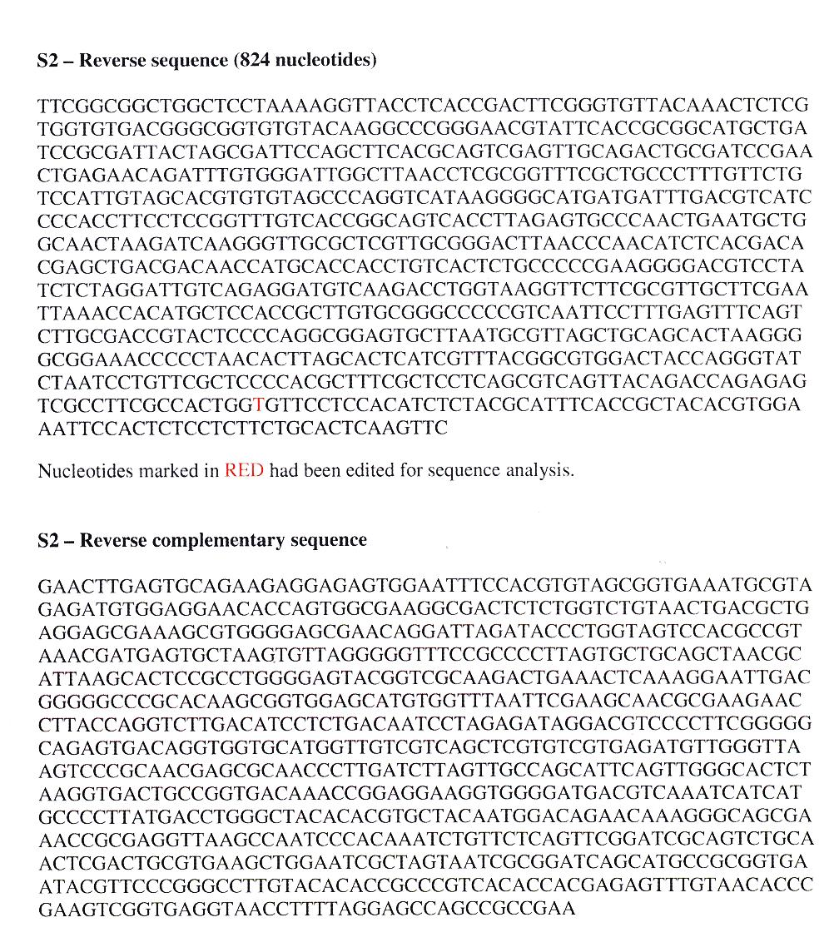
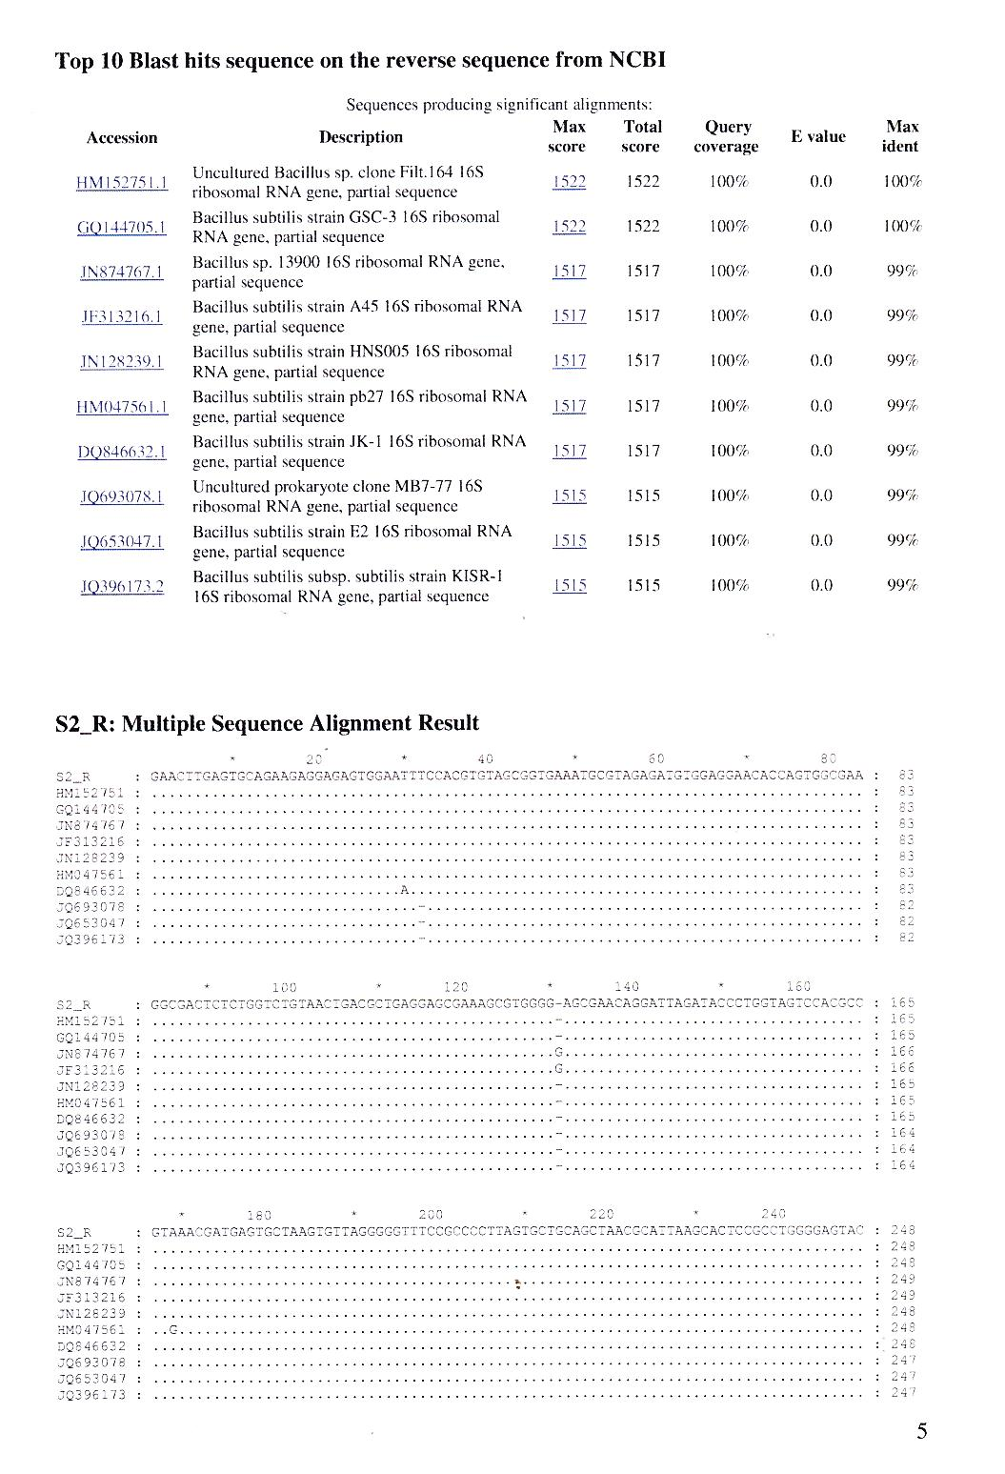
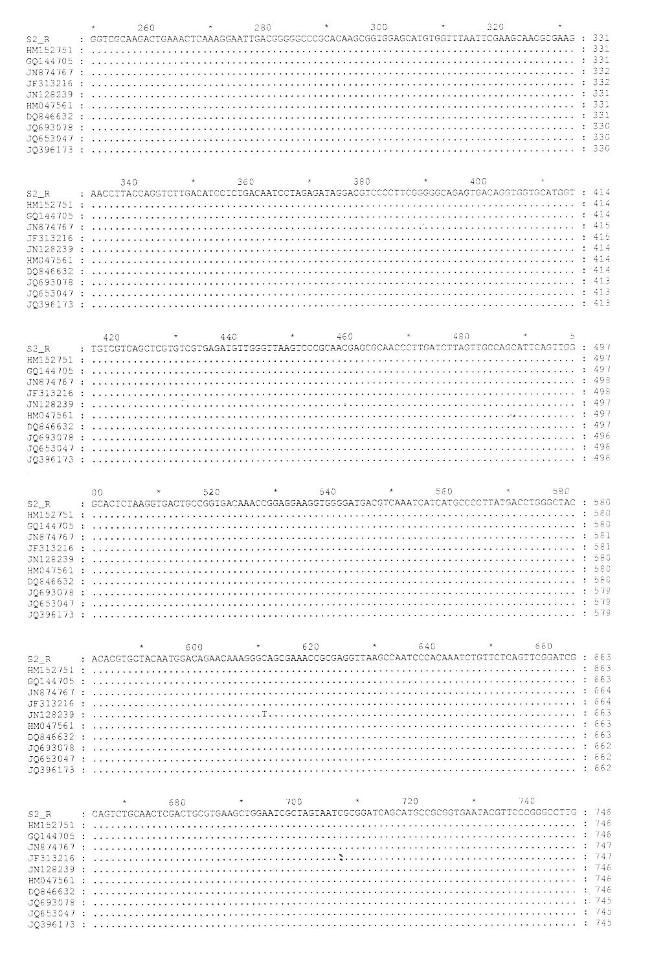
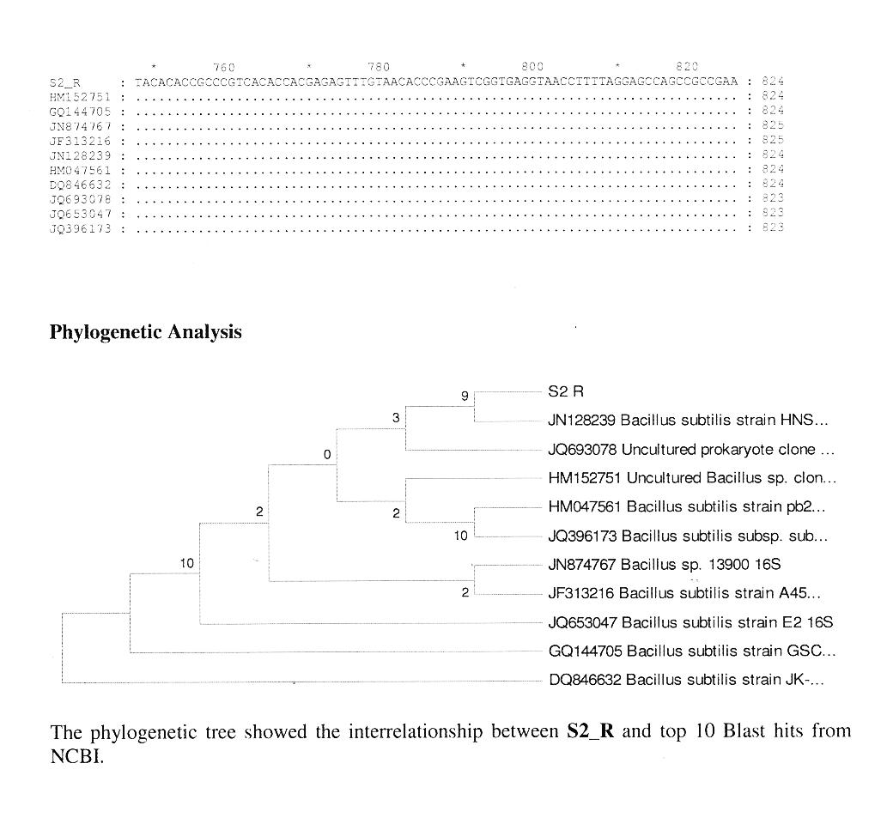

Appendix B
Scanning of the cephalexin absorbance among different wavelengths

Figure B1 | The optimal absorbance of cephalexin among different wavelengths.

Appendix C
Calibration curve of the cephalexin and cephalosporic acid

Figure C1 | Calibration curve of the cephalexin and cephalosporic acid in 0.1 M phosphate buffer: pH = 7.0, T = 30°C, λ = 340 nm.

One unit of β-lactamase concentration was defined as the amount of enzyme that could hydrolyse 1µmol of cephalexin at 30 °C and pH 7.0 in 1 min. The product of the hydrolysis reaction, cephalosporic acid, also gives an absorbance at 340 nm, therefore, the difference of the slopes is taken, y₁-y₂ = 0.2135 A_{λ}. The activity of enzyme, U mL⁻¹ is given by 1U = A_{λ} × 0.2135 × Dilution factor.

