As shown in equation (4), when the expression of f(a,b,c) is known, the model of the transmission of UVA and blue light in water can be established. The model was modeled by mathematical function simulation, measuring the intensity of light with different locations, different water quality and light intensity. The experimental device is shown in Figure S1.
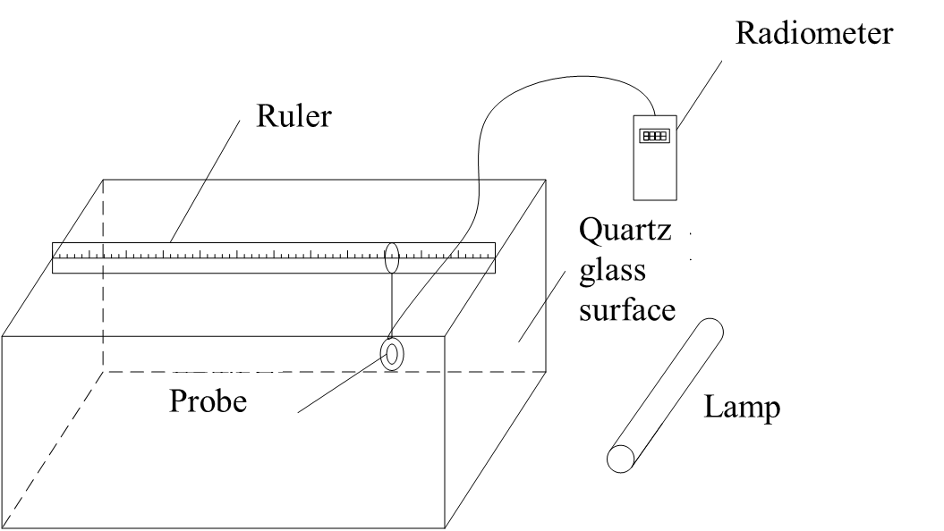
Figure S1 The experimental device to measure light intensity

The transmission model of UVA in the water
The distances were set as 0, 15, 30, 45 and 56 cm and the turbidities were 1.1, 3.2, 6.2, 10.2, 25.8, 28.3 and 49.4 NTU. When the light was UVA, the data were shown in Table S1.
Table S1 UVA intensity at different distances with different turbidity (TOC = 0 mg / L)
Turbidity（NTU） | Distance（cm） | Light intensity（μw/cm²） |  |  |  | Turbidity（NTU） | Distance（cm）  1# | Light intensity（μw/cm²）
 |  | 1# | 2# |  |  |  |  |  |  | 2#
1.1 | 0 | 65.4 |  | 200 |  | 25.8 | 0 | 60.4 | 240
 | 15 | 46.7 |  | 136 |  |  | 15 | 27.9 | 84.2
 | 30 | 33.2 |  | 92.7 |  |  | 30 | 13.1 | 29.8
 | 45 | 24.1 |  | 64.2 |  |  | 45 | 5.9 | 9.4
 | 56 | 19.3 |  | 50.8 |  |  | 56 | 3.3 | 4.2
3.2 | 0 | 72.1 |  | 195 |  | 28.3 | 0 | 100 | 202
 | 15 | 49.3 |  | 120 |  |  | 15 | 36.3 | 67.8
 | 30 | 29.1 |  | 80.1 |  |  | 30 | 12.8 | 20.2
 | 45 | 20.4 |  | 50.9 |  |  | 45 | 5.2 | 9.2
 | 56 | 15.0 |  | 38.4 |  |  | 56 | 2.5 | 4.8
6.2 | 0 | 60.1 |  | 200 |  | 49.4 | 0 | 108 | 200
 | 15 | 38.2 |  | 111 |  |  | 15 | 33.3 | 50.5
 | 30 | 24.9 |  | 63.1 |  |  | 30 | 10.2 | 12.1
 | 45 | 14.5 |  | 32.4 |  |  | 45 | 2.7 | 3.6
 | 56 | 10.2 |  | 19.9 |  |  | 56 | 1.1 | 1.5
10.2 | 0 | 75.3 |  | 210
 | 15 | 42.2 |  | 112.7
 | 30 | 23.5 |  | 61.8
 | 45 | 13.1 |  | 33.3
 | 56 | 8.6 |  | 21.3
The relationship between the light intensity I (μw/cm²), the initial light intensity I₀ (μw/cm²) and the distance b (cm) at each turbidity was shown in Table S2.
Table S2 The relationship between light intensity, initial light intensity, turbidity and measurement position under UVA irradiation
Turbidity（NTU） | Fitting function | R² | Index coefficient
1.1 | I = I₀e^{-0.02425b} | >0.99 | -0.02425
3.2 | I = I₀e^{-0.02796b} | >0.99 | -0.02796
6.2 | I = I₀e^{-0.03325b} | >0.99 | -0.03325
10.2 | I = I₀e^{-0.03962b} | >0.99 | -0.03962
25.8 | I = I₀e^{-0.060b} | >0.99 | -0.06
28.3 | I = I₀e^{-0.06625b} | >0.99 | -0.06625
49.4 | I = I₀e^{-0.08425b} | >0.99 | -0.08425
Take turbidity and index coefficient to curve fit. The result was shown in Figure S2. The curve was shown in equation (S-1)
y=0.0185－0.0018a+1×10⁻⁵a² (R²=0.9983) （S-1）
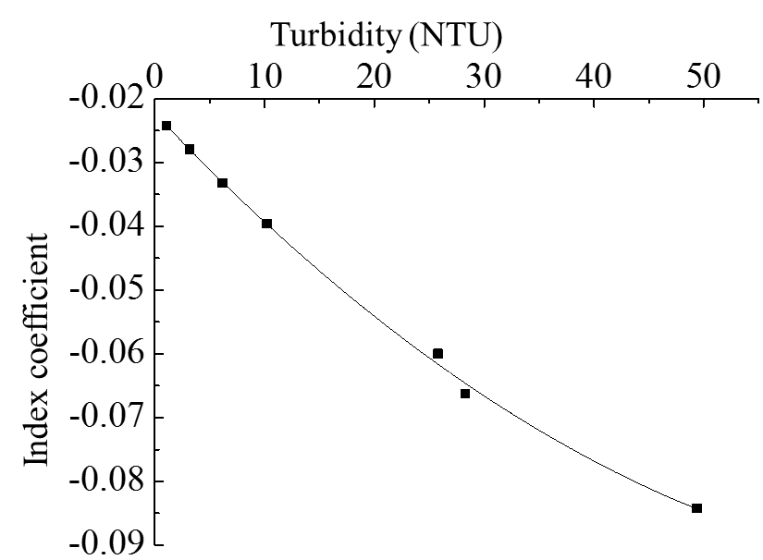
Figure S2 The curve fitting of turbidity and index coefficient under UVA irradiation
It can be seen that the R² was more than 0.99, which means that relevance between turbidity and index coefficient was high. Thus, the following equation can be introduced:
lgI = lgI₀ + (0.0185－0.0018a + 1×10⁻⁵a²)b （S-2）
where I₀ is the initial light intensity; I is the light intensity at measurement position; a is turbidity; b is the distance between measurement position and start point.
The light intensity was measured at the same turbidity value and different TOC value. After the curve fitting, the index coefficients of turbidity and TOC were showan in Table S3.
Table S3 The index coefficients of turbidity and TOC under UVA irradiation
Turbidity（NTU） | TOC（mg/L）
 | 0 | 2 | 4 | 6 | 8
1 | −0.024 | −0.088 | −0.152 | −0.220 | −0.282
10 | −0.040 | −0.103 | −0.173 | −0.236 | −0.300
23 | −0.060 | −0.127 | −0.195 | −0.262 | −0.327
35 | −0.073 | −0.137 | −0.201 | −0.268 | −0.338
49 | −0.086 | −0.153 | −0.220 | −0.286 | −0.350
Based on the index coefficient at 0 mg/L TOC, with an increase of 2 mg/L per TOC, the index coefficient will probably decrease 0.066. Therefore, the relationship between the irradiation intensity of UVA in water, the turbidity and TOC was as shown in equation (5).
lgI = lgI₀ + (0.0185－0.0018a + 10⁻⁵a² － 0.033c)b (5)
where I₀ is the initial light intensity; I is the light intensity at measurement position; a is turbidity; b is the distance between measurement position and start point; c is TOC value.

The transmission model of blue light in the water
When the light was blue light, the distances were set as 0, 15, 30, 45 and 56 cm and the turbidities were 1.1, 11.3, 21.6, 33.6, 48.7 and 61.7 NTU. The results were shown in Table S4.
Table S4 Blue light intensity at different distances with different turbidity (TOC = 0 mg / L)
Turbidity（NTU） | Distance（cm） | Light intensity（μw/cm²） |  |  |  | Turbidity（NTU） | Distance（cm）  1# | Light intensity（μw/cm²）
 |  | 1# | 2# |  |  |  |  |  |  | 2#
1.1 | 0 | 2460 |  | 1190 |  | 33.6 | 0 | 1640 | 2940
 | 15 | 1740 |  | 850 |  |  | 15 | 910 | 1330
 | 30 | 1310 |  | 770 |  |  | 30 | 435 | 684
 | 45 | 850 |  | 610 |  |  | 45 | 210 | 345
 | 56 | 670 |  | 550 |  |  | 56 | 170 | 252
11.3 | 0 | 1300 |  | 3350 |  | 48.7 | 0 | 3190 | 1763
 | 15 | 830 |  | 1930 |  |  | 15 | 1330 | 930
 | 30 | 620 |  | 1240 |  |  | 30 | 626 | 372
 | 45 | 430 |  | 792 |  |  | 45 | 285 | 177
 | 56 | 334 |  | 625 |  |  | 56 | 175 | 120
21.6 | 0 | 3700 |  | 1751 |  | 61.7 | 0 | 1700 | 3430
 | 15 | 1600 |  | 1020 |  |  | 15 | 695 | 1390
 | 30 | 880 |  | 595 |  |  | 30 | 304 | 551
 | 45 | 470 |  | 360 |  |  | 45 | 132 | 243
 | 56 | 408 |  | 268 |  |  | 56 | 87 | 142
The relationship between the light intensity I (μw / cm²), the initial light intensity I₀ (μw / cm²) and the distance b (cm) at each turbidity was shown in Table S5.

Table S5 The relationship between light intensity, initial light intensity, turbidity and measurement position under blue light irradiation
Turbidity（NTU） | Fitting function | R² | Index coefficient
1.1 | I = I₀e^{-0.016b} | >0.99 | -0.016
11.3 | I = I₀e^{-0.026b} | >0.99 | -0.026
21.6 | I = I₀e^{-0.036b} | >0.99 | -0.036
33.6 | I = I₀e^{-0.043b} | >0.99 | -0.043
48.7 | I = I₀e^{-0.051b} | >0.99 | -0.051
61.7 | I = I₀e^{-0.056b} | >0.99 | -0.056
Take turbidity and index coefficient to curve fit. The result was shown in Figure S3. The curve was shown in equation (S-3)
y=－0.0149－0.0011a+7×10⁻⁶a² (R²=0.9987) （S-3）
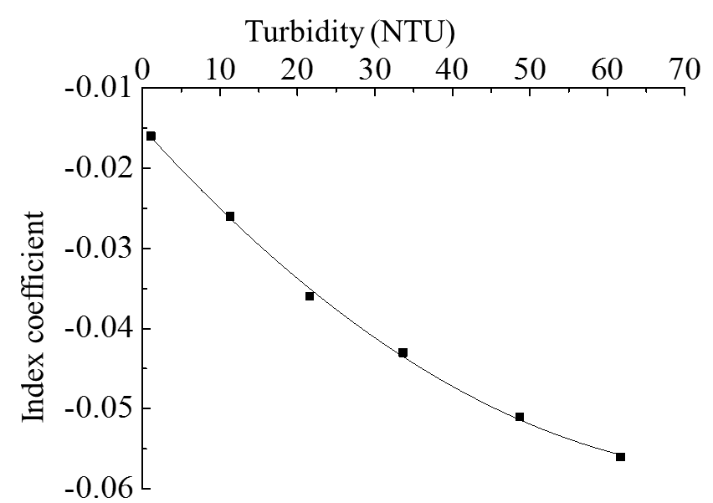
Figure S3 The curve fitting of turbidity and index coefficient under blue light irradiation
It can be seen that the R² was more than 0.99, which means that relevance between turbidity and index coefficient was high. Thus, the following equation can be introduced:
lgI = lgI₀ + (－0.0149－0.0011a + 7×10⁻⁶a²)b （S-4）
where I₀ is the initial light intensity; I is the light intensity at measurement position; a is turbidity; b is the distance between measurement position and start point.
The light intensity was measured at the same turbidity value and different TOC value. After the curve fitting, the index coefficients of turbidity and TOC were shown in Table S6.
Table S6 The index coefficients of turbidity and TOC under blue light irradiation
Turbidity（NTU） | TOC（mg/L）
 | 0 | 2 | 4 | 6 | 8
1.1 | −0.016 | −0.03 | −0.042 | −0.055 | −0.067
11.2 | −0.026 | −0.039 | −0.051 | −0.064 | −0.077
21.6 | −0.035 | −0.046 | −0.061 | −0.074 | −0.086
37.4 | −0.046 | −0.057 | −0.068 | −0.081 | −0.093
49 | −0.051 | −0.062 | −0.073 | −0.085 | −0.099
Based on the index coefficient at 0 mg/L TOC, with an increase of 2 mg/L per TOC, the index coefficient will probably decrease 0.012. Therefore, the relationship between the irradiation intensity of blue light in water, the turbidity and TOC was as shown in equation (6).
lgI = lgI₀ + (－0.0149－0.0011a + 7 × 10⁻⁶a² － 0.006c)b (6)
where I₀ is the initial light intensity; I is the light intensity at measurement position; a is turbidity; b is the distance between measurement position and start point; c is TOC value.

