APPENDIX A
Appendix Figure 1: Map of Texas Zip Codes and their Center Point
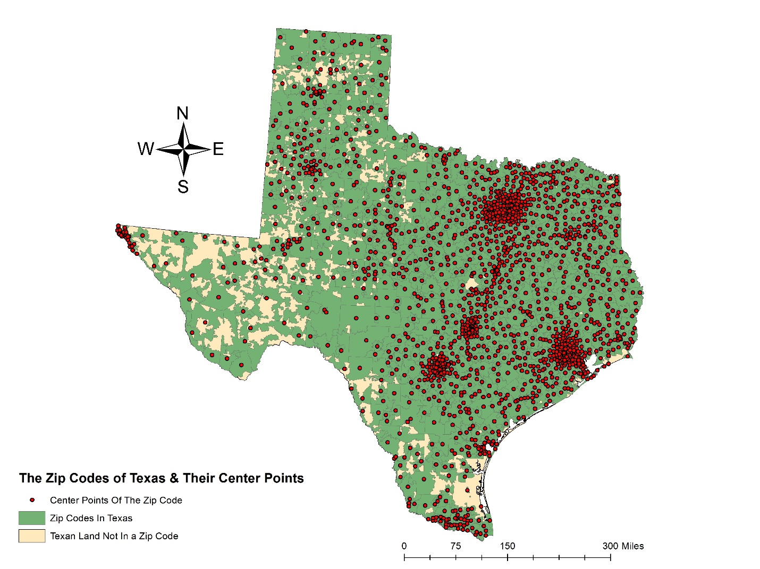
Source: United States Census Bureau Tiger/Line Files

Appendix Figure 2: Map of Texas Zip Code Population Density, by Population Quantiles
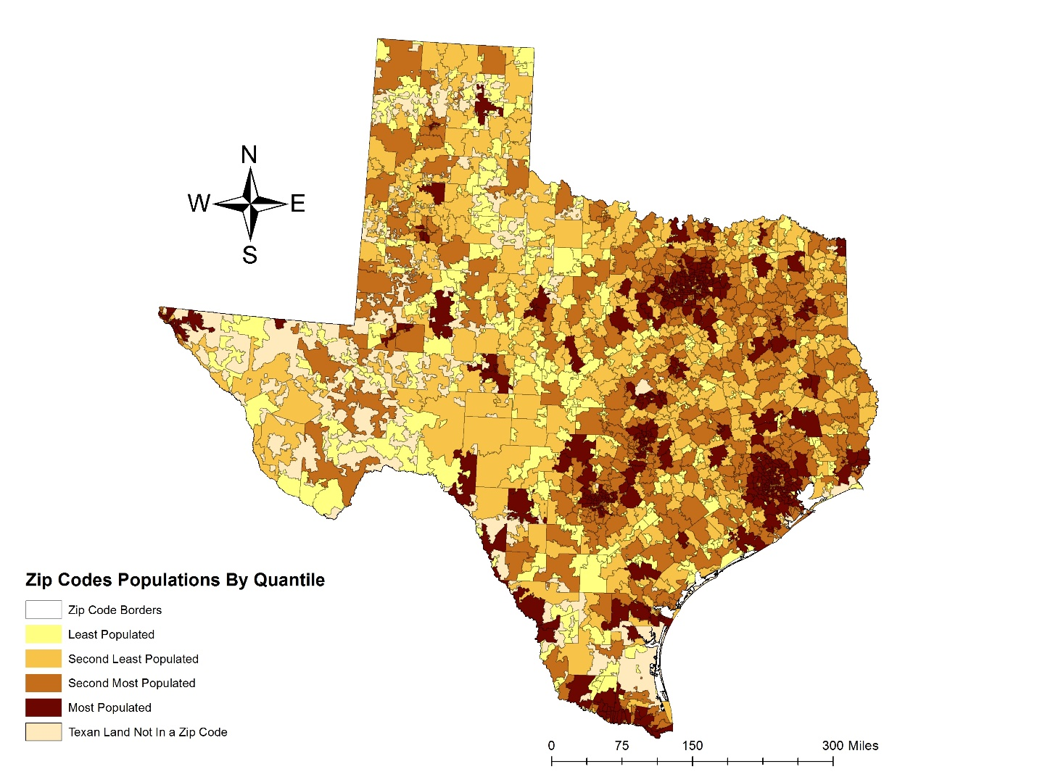
Source: United States Census Bureau Tiger/Line Files, American Fact Finder (Texas Zip Code Population 2013)

Appendix Figure 3: Map of Survey Respondents by Texas Zip Codes
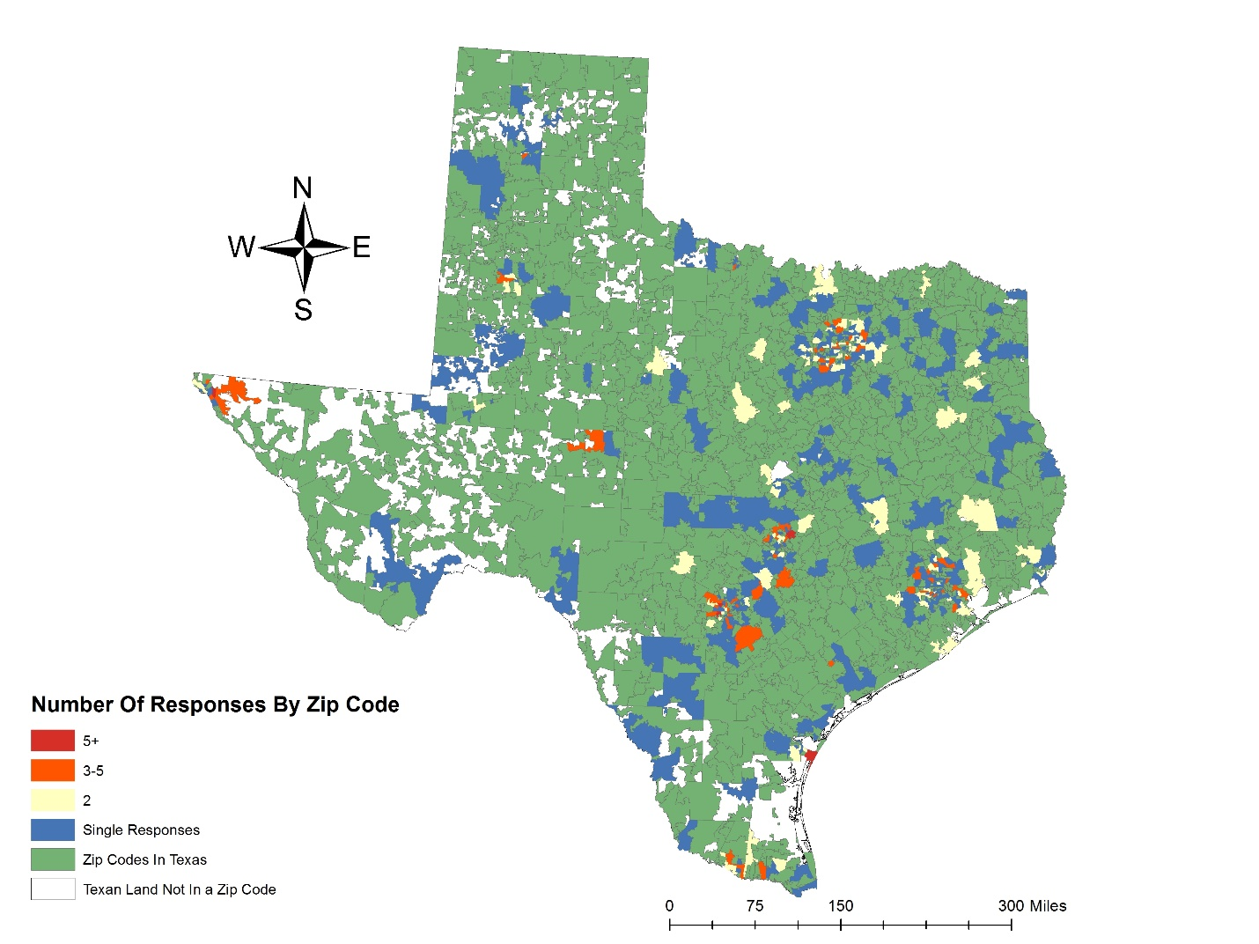
Source: United States Census Bureau Tiger/Line Files

Appendix Figure 4: Map of Rivers and Streams in Texas
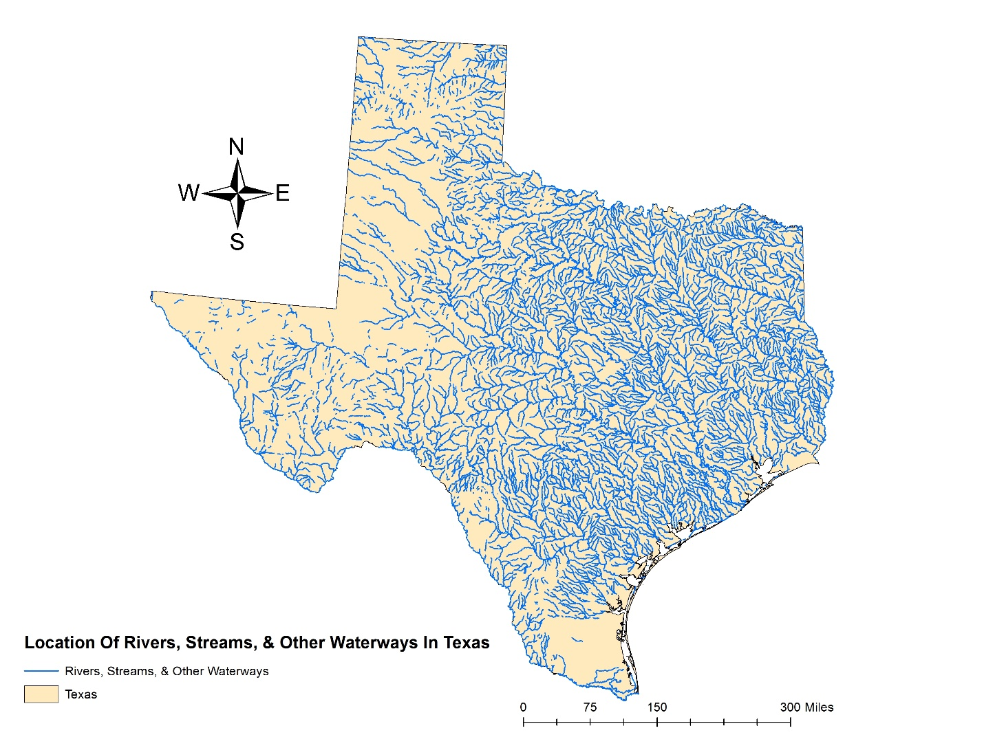
Source: United States Census Bureau Tiger/Line Files, United States Geological Survey "The National Map"

Appendix Figure 5: Map of Texas Waterbodies
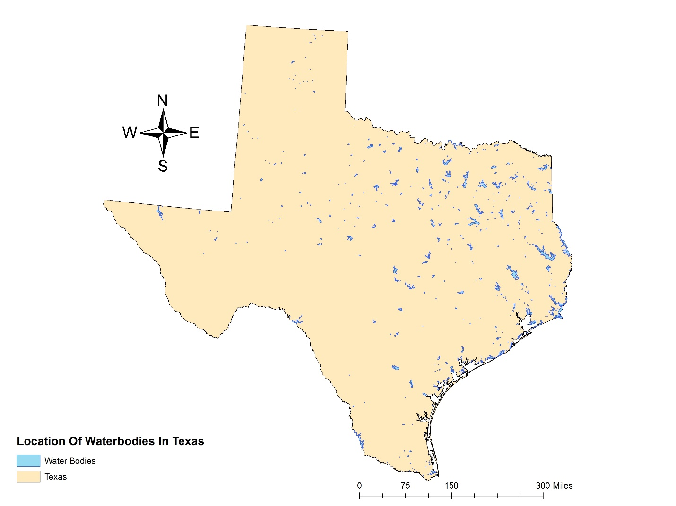
Source: United States Census Bureau Tiger/Line Files, United States Geological Survey "The National Map"

APPENDIX B
Appendix Table 1: Variable Definitions
Variable |  | Operation
Independent Variables
 | Water Bodies | The geographical distance in meters from the center point of a respondent’s zip code to the nearest body of water (lakes, reservoirs, etc.).
 | Rivers and Streams | The geographical distance in meters from the center point of a respondent’s zip code to the nearest river or stream.
 | Concern for Water | Measured using an 11-point scale. Respondents were asked to indicate how concerned they considered themselves to be on the issue of water quality and availability, with 10 = extremely concerned, and 0 = not at all concerned.
 | Environmental Group | Measured nominally as 1 = yes, and 0 = no. Respondents were asked, “Are you a member of an environmental interest group?”
 | Drought Experience | Measured as the number of years since the respondent experienced a drought. Respondents were asked, “When did you last experience a drought or water shortage in your community?” The answer choices were: 1) “Never experienced a drought or water shortage;” 2) “Within the past 12 months;” 3) “1 to less than 2 years ago;” 4) “2–5 years ago;” 5) “6–9 years ago;” and 6) “10 years or more ago.” The answer choices were recoded such that 1 = the age of the respondent, 2 = .5, 3 = 1.5, 4 = 3.5, 5 = 7.5, and 6 = 10.
Demographic Variables
 | Female | Measured nominally as 1 = female, and 0 = male.
 | Income | Measured as the estimated annual household income (19 ordered categories representing $5,000 increments through $100,000, and $25,000 increments after that)
 | Married | Measured nominally as 1 = married, and 0 = not married
 | Ideology | Measured as a 7-point scale, with 0 = strongly liberal, and 6 = strongly conservative
 | White | Measured nominally as 1 = white, and 0 = all others
 | Rural | Measured normally as 1 = lives in rural area, and 0 = all others
 | Education | Measured in years of education.

