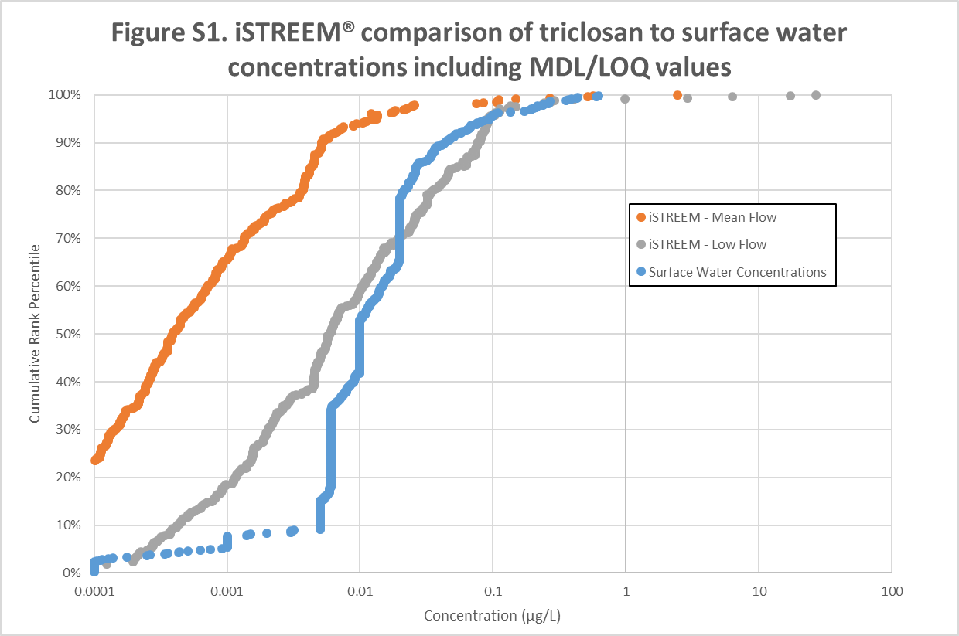
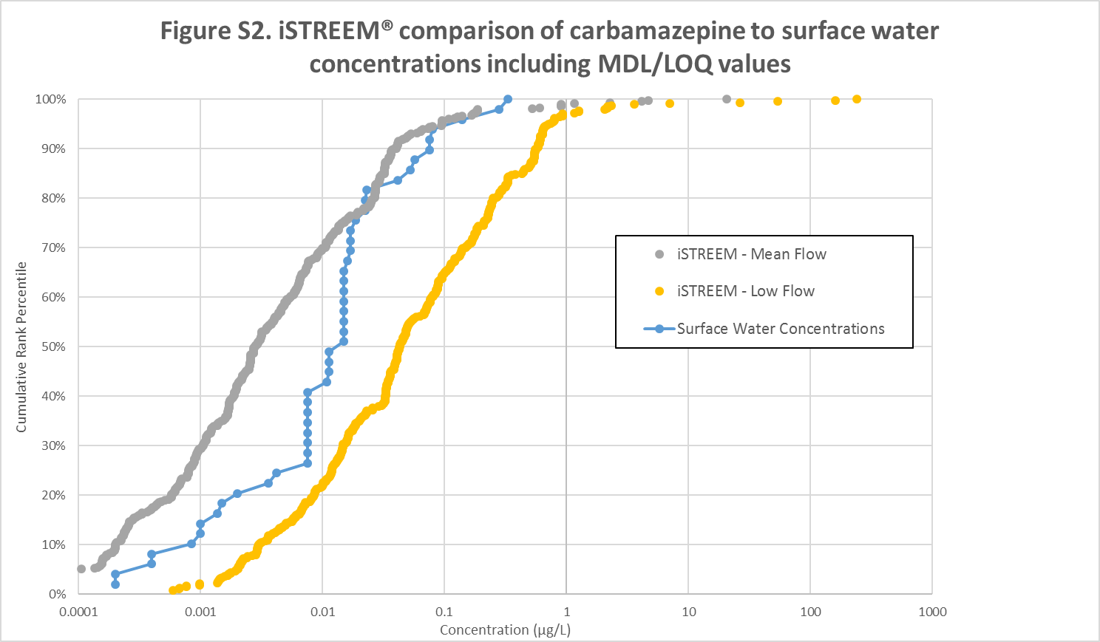
Supplementary material
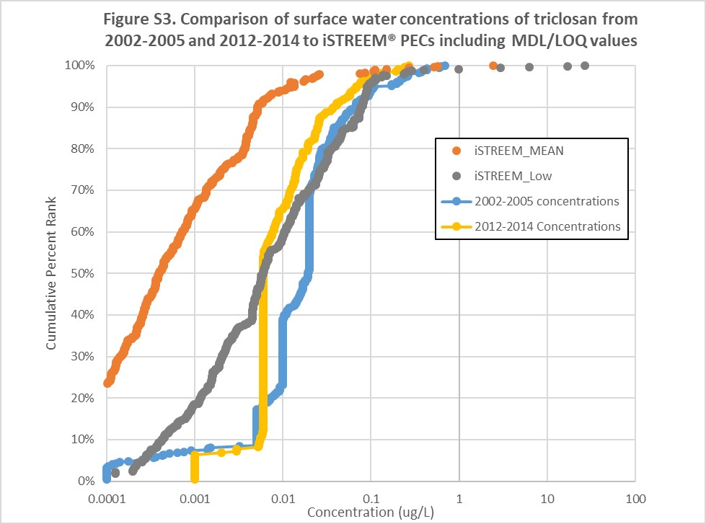
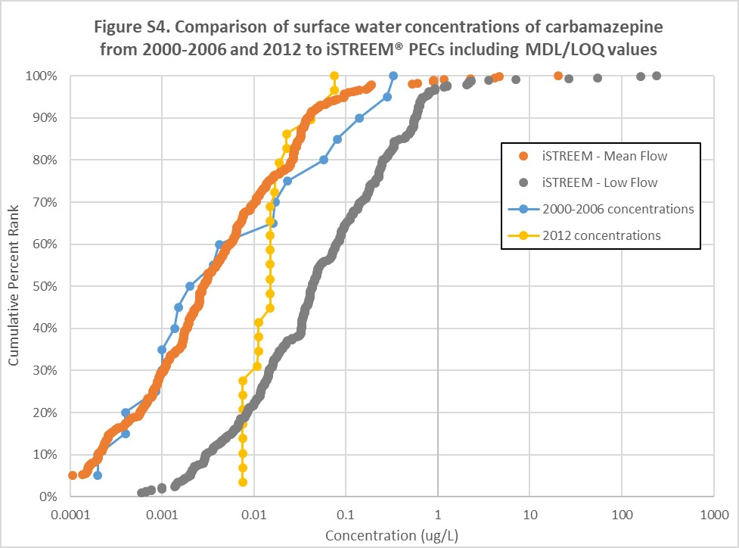
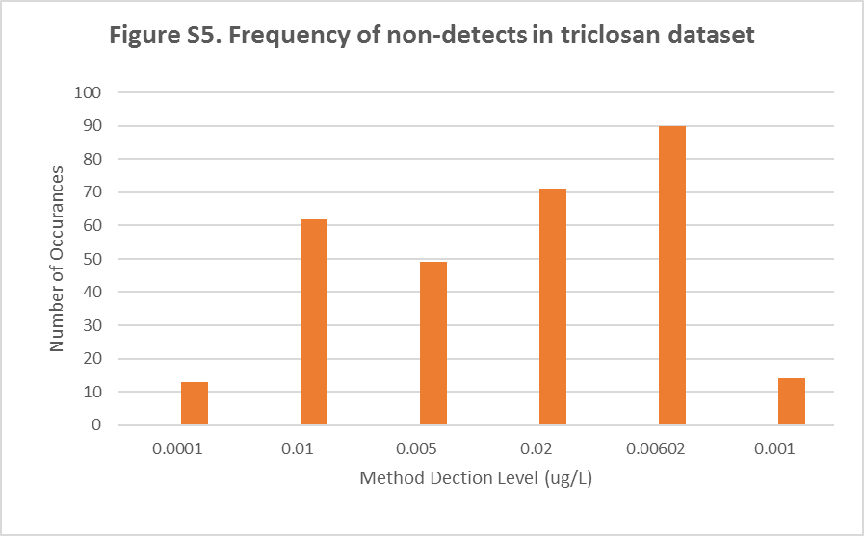

Figure S1 | iSTREEM® comparison of triclosan to surface water concentrations including MDL/LOQ values.
Figure S2 | iSTREEM® comparison of carbamazepine to surface water concentrations including MDL/LOQ values.
Figure S3 | Comparisons of surface water concentrations of triclosan from 2002 to 2005 and 2012 to 2014 to iSTREEM® including MDL/LOQ values.
Figure S4 | Comparisons of surface water concentrations of carbamazepine from 2000 to 2006 and 2012 to iSTREEM® PEC including MDL/LOQ values.
Figure S5 | Frequency of non-detects in triclosan dataset.

