Supplement
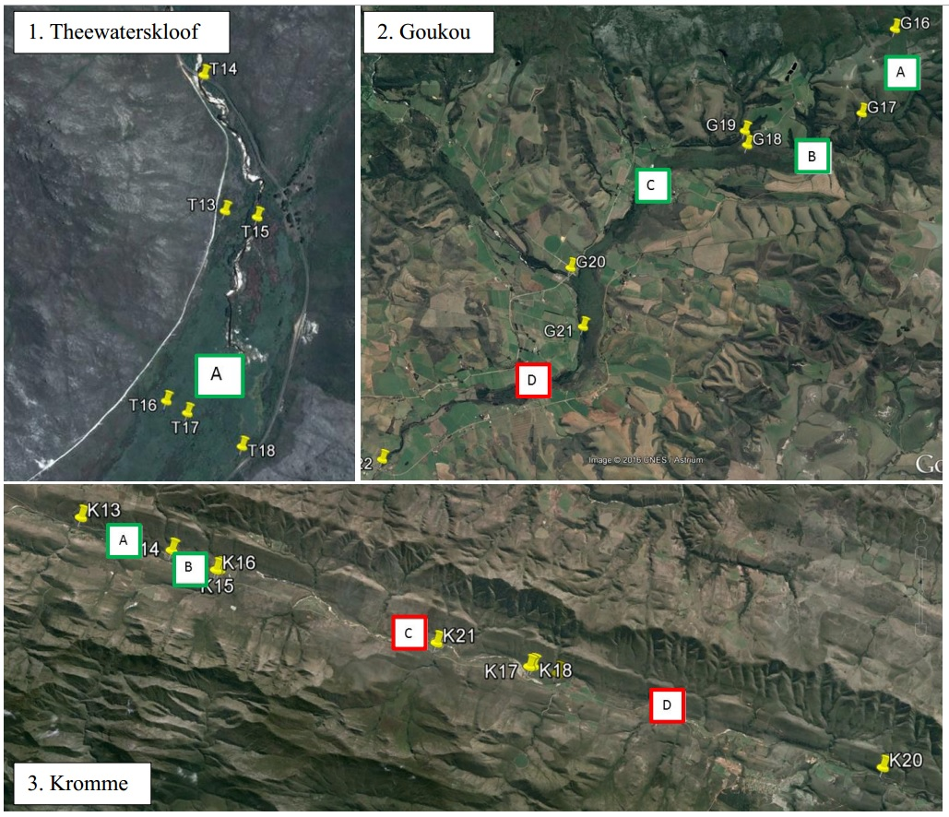
Figure A1 | The three South African palmiet wetlands and the sections considered in this study (locations of the catchments can be seen in Figure 1). Theewaterskloof wetland, 1.6 km in length (1 section), the Goukou wetland, 15 km in length (4 sections), and the Kromme wetland, 30 km in length (4 sections). Red boxes indicate degraded wetland sections and green boxes indicate pristine wetland sections according to the criteria of channel erosion.

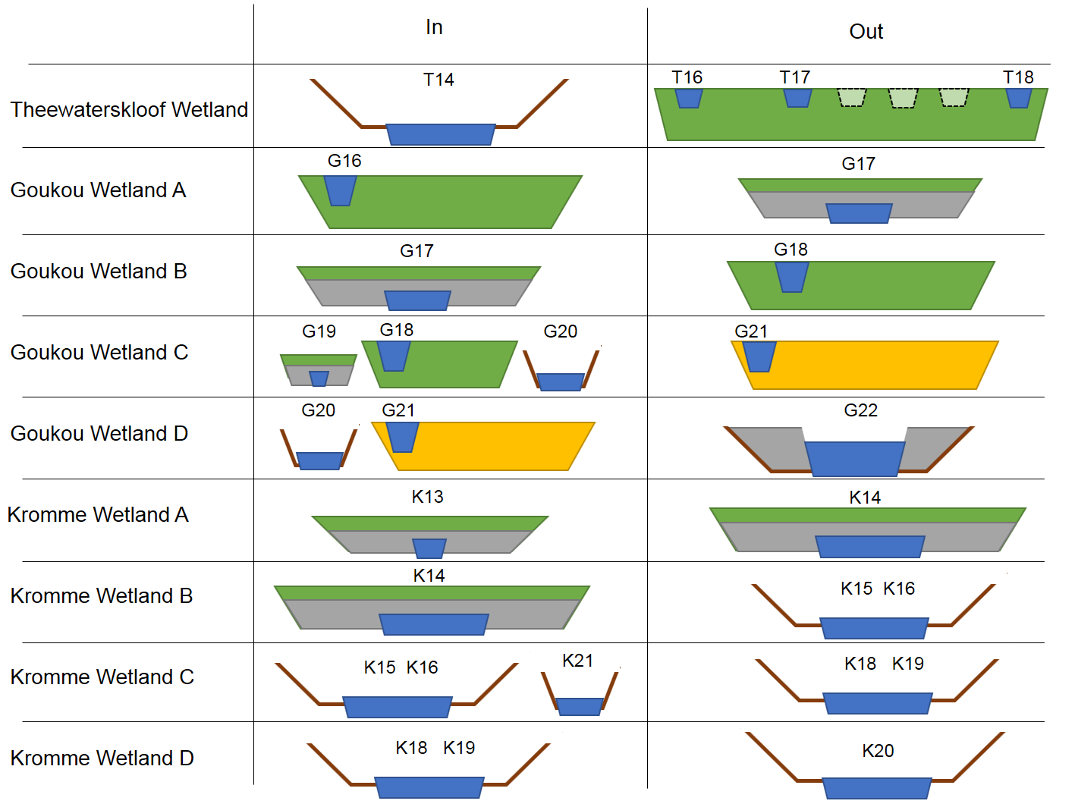
Figure A2 | Schematic models for the mass balance type approach used to quantify water purification in this study of South African palmiet wetlands. Sampling points and wetland names correspond to those in Figure 1 and Figure A1. ‘In’ represents the water entering the stretch of wetland (labelled on the left) and ‘out’ indicates the water leaving the stretch of wetland being investigated. Separate cross-sections indicate tributaries joining the main wetland. Wetlands with intact peatlands are shown in green, while wetlands degraded by alien invasion (more-or-less intact peatbeds) are in yellow. Brown lines indicate that the wetland has become channelised. More than one channel is indicative of braided channels in the wetland. Unsampled channels are shown with stippled lines. Grey indicates a canal or impoundment in the wetland.

Table A1 | Results from the instantaneous mass balance sampling of three South African palmiet wetlands: Theewaterskloof (1 section), Goukou (4 sections) and Kromme (4 sections) wetlands. Parameters are all reported as change over the stretch of wetland, i.e. inflow − outflow, all given in g/s (parameter g/l * discharge l/s) except for pH, conductivity (µS/cm) and discharge (l/s). Negative values (red) indicate that the wetland is a source for that parameter (or that it increases), positive values (green) indicate that the wetland is a sink for that parameter (or that it decreases).
 |  | Small scale | Medium scale |  |  |  | Large scale
Parameter | Unit | Theewaterskloof | Goukou A | Goukou B | Goukou C | Goukou D | Kromme A | Kromme B | Kromme C | Kromme D
Wetland type: |  | Pristine | Pristine | Pristine | Pristine | Degraded | Pristine | Pristine | Degraded | Degraded
Discharge | l/s | 2154.38 | 99.77 | −133.86 | 191.43 | −180.92 | 1.37 | 93.88 | 104.35 | −643.57
pH | – | 1.31 | 0.91 | −0.6 | −0.94 | −1.59 | 0.90 | −0.09 | −1.47 | 0.00
Conductivity | µS/cm | 22.33 | −7.60 | −28.30 | −330.20 | −1089.00 | −31.50 | −15.50 | −74.25 | −69.50
Ca | g/s | 0.73 | 0.04 | −0.14 | −0.11 | −4.56 | −0.07 | 0.14 | 0.31 | −3.32
K | g/s | 25.65 | 0.19 | −0.16 | −0.04 | −1.39 | 0.14 | 0.04 | 0.17 | −1.52
Mg | g/s | 1.02 | 0.09 | −0.28 | −0.03 | −7.28 | −0.12 | 0.29 | 0.63 | −4.35
Fe | g/s | 0.11 | 0.01 | −0.24 | 0.21 | 0.00 | 0.00 | 0.02 | 0.02 | −0.39
Dissolved Si | g/s | 3.37 | 0.28 | −0.56 | 0.71 | −0.22 | −0.17 | 0.34 | 0.62 | −1.73
Zn | g/s | 0.09 | 0.00 | 0.00 | 0.01 | 0.00 | 0.00 | 0.00 | 0.00 | 0.00
Cu | g/s | 0.00 | 0.00 | 0.00 | 0.00 | 0.00 | 0.00 | 0.00 | 0.00 | 0.00
Al | g/s | 0.22 | 0.00 | −0.08 | 0.10 | 0.00 | −0.01 | 0.01 | 0.02 | −0.03
Mn | g/s | 0.02 | 0.01 | 0.00 | 0.00 | −0.01 | 0.00 | 0.00 | 0.00 | −0.01
Na | g/s | 8.68 | 0.72 | −1.98 | −0.22 | −58.93 | −0.64 | 1.89 | 4.92 | −32.36
Cl | g/s | 32.62 | 1.61 | −3.60 | 0.62 | −90.20 | −1.23 | 3.80 | 9.62 | −62.53
SO₄²⁻ | g/s | 12.86 | 0.30 | −1.83 | 1.88 | −14.23 | 0.04 | −0.19 | 1.19 | −5.29
Chemical oxygen demand | g/s | 14.19 | 1.21 | −7.14 | 7.44 | −4.59 | −0.50 | 0.87 | 1.58 | −11.04
Total P | g/s | 0.37 | 0.01 | −0.02 | 0.02 | −0.02 | 0.00 | 0.02 | 0.03 | −0.12
Kjeldahl N | g/s | 1.20 | 0.04 | −0.16 | 0.15 | −0.11 | 0.00 | 0.04 | 0.10 | −0.52
PO₄-P | g/s | 0.07 | 0.00 | 0.00 | 0.00 | 0.00 | 0.00 | 0.00 | 0.01 | −0.02
NH₄-N | g/s | 0.13 | 0.01 | −0.02 | 0.02 | 0.00 | 0.00 | 0.01 | 0.01 | −0.04
NO₃-N | g/s | −0.04 | −0.01 | 0.01 | −0.02 | 0.03 | 0.00 | 0.00 | 0.07 | −0.13

Table A2. Water quality parameters for three South African palmiet wetlands: Theewaterskloof, Goukou and Kromme wetlands. Abbreviations: DO – dissolved oxygen, COD – chemical oxygen demand. For sampling locations see Figure A1. Discharge is already corrected for roughness (factor 0.9).
Parameter | Units | T13 | T14 | T15 | T16 | T17 | T18 | G16 | G17 | G18 | G19 | G20 | G21 | G22
Latitude | DD | -33.95385 | -33.948553 | -33.954089 | -33.961294 | -33.961769 | -33.963064 | -34.004247 | -34.021289 | -34.028103 | -34.025281 | -34.053467 | -34.065217 | -34.092411
Longitude | DD | 19.170131 | 19.169153 | 19.171633 | 19.167319 | 19.168308 | 19.170914 | 21.415242 | 21.407619 | 21.380208 | 21.379608 | 21.338172 | 21.341517 | 21.294031
pH | – | 6.5 | 8.1 | 7.1 | 7.0 | 7.7 | 5.8 | 5.5 | 4.5 | 5.1 | 4.3 | 6.2 | 6.4 | 7.9
Conductivity | µS/cm | 40.0 | 59.0 | 30.0 | 28.0 | 30.0 | 52.0 | 72.1 | 79.7 | 108.0 | 85.2 | 541.0 | 649.0 | 1684.0
Discharge | l/s | – | 2946 | – | 90 | 216 | 90 | 154 | 54 | 188 | 222 | 60 | 90 | 270
DO | mg/l | 55.3 | 77.1 | 86.6 | 95.0 | 67.0 | 103.0 | 83.0 | 73.0 | 101.6 | 103.0 | 103.1 | 76.1 | 93.2
Ca | mg/l | 0.39 | 0.32 | 0.32 | 0.27 | 0.28 | 0.31 | 0.39 | 0.44 | 0.88 | 0.45 | 3.85 | 6.67 | 18.76
K | mg/l | 3.32 | 9.12 | 3.60 | 2.11 | 1.86 | 0.13 | 1.98 | 2.04 | 1.43 | 0.52 | 2.09 | 6.45 | 6.80
Mg | mg/l | 0.49 | 0.47 | 0.49 | 0.41 | 0.46 | 0.50 | 0.97 | 1.08 | 1.79 | 1.13 | 9.24 | 11.21 | 30.41
Fe | mg/l | 1.00 | 0.14 | 0.19 | 0.30 | 0.30 | 0.60 | 0.18 | 0.39 | 1.40 | 0.37 | 0.69 | 1.49 | 0.40
DSi | mg/l | 0.99 | 1.63 | 1.73 | 1.90 | 1.74 | 1.82 | 2.82 | 2.84 | 3.79 | 2.36 | 1.90 | 2.26 | 1.51
Zn | mg/l | 0.01 | 0.03 | 0.02 | 0.01 | 0.01 | 0.01 | 0.01 | 0.00 | 0.02 | 0.05 | 0.01 | 0.01 | 0.00
Cu | mg/l | 0.001 | 0.001 | 0.001 | 0.003 | 0.001 | 0.001 | 0.001 | 0.001 | 0.001 | 0.000 | 0.001 | 0.001 | 0.001
Al | mg/l | 0.31 | 0.11 | 0.11 | 0.22 | 0.13 | 0.12 | 0.09 | 0.23 | 0.52 | 0.25 | 0.06 | 0.08 | 0.02
Mn | mg/l | 0.01 | 0.01 | 0.01 | 0.01 | 0.01 | 0.02 | 0.06 | 0.01 | 0.02 | 0.02 | 0.05 | 0.06 | 0.04
Na | mg/l | 3.30 | 3.90 | 3.91 | 3.08 | 3.62 | 3.81 | 7.43 | 7.91 | 12.79 | 9.06 | 69.46 | 82.51 | 243.80
Cl | mg/l | 12.30 | 13.70 | 10.60 | 8.40 | 9.10 | 12.80 | 16.90 | 18.30 | 24.40 | 17.80 | 133.70 | 140.90 | 379.40
SO₄²⁻ | mg/l | 19.90 | 7.50 | 19.00 | 16.40 | 11.00 | 8.50 | 2.90 | 2.70 | 10.50 | 5.00 | 17.50 | 12.90 | 57.40
COD | mg/l | 34.70 | 10.90 | 9.46 | 63.70 | 10.80 | 9.96 | 14.40 | 18.50 | 43.30 | 26.90 | 7.76 | 30.90 | 24.70
Total P | mg/l | 0.20 | 0.17 | 0.17 | 0.22 | 0.17 | 0.17 | 0.14 | 0.13 | 0.15 | 0.15 | 0.17 | 0.39 | 0.20
Kjeldahl N | mg/l | 1.17 | 0.61 | 0.52 | 1.55 | 0.52 | 0.51 | 0.41 | 0.41 | 0.98 | 0.63 | 0.45 | 1.08 | 0.69
PO₄-P | mg/l | 0.03 | 0.03 | 0.03 | 0.03 | 0.03 | 0.03 | 0.03 | 0.03 | 0.03 | 0.03 | 0.03 | 0.09 | 0.03
NH₄-N | mg/l | 0.06 | 0.05 | 0.04 | 0.04 | 0.02 | 0.03 | 0.05 | 0.02 | 0.11 | 0.03 | 0.03 | 0.07 | 0.03
NO₃-N | mg/l | 0.01 | 0.01 | 0.06 | 0.11 | 0.11 | 0.00 | 0.01 | 0.20 | 0.02 | 0.00 | 0.04 | 0.41 | 0.00

Table A2 continued…
Parameter | Units | K13 | K14 | K15 | K16 | K17 | K18 | K19 | K20 | K21
Latitude | DD | –33.867281 | −33.878272 | −33.884728 | −33.884458 | −33.91684517 | −33.91649776 | −33.919075 | −33.950278 | −33.90894277
Longitude | DD | 24.016944 | 24.053292 | 24.070878 | 24.072269 | 24.19655124 | 24.19803219 | 24.208031 | 24.339311 | 24.1592335
pH | – | 6.5 | 5.6 | 5.6 | 5.8 | 6.7 | 7.1 | 7.5 | 7.3 | 5.9
Conductivity | µS/cm | 129.9 | 161.4 | 179.8 | 174.0 | 1144.0 | 237.0 | 262.0 | 319.0 | 173.6
Discharge | l/s | 124 | 122 | 26 | 31 | – | 162 | 149 | 155 | 231
DO | mg/l | 87.0 | 99.0 | 90.4 | 94.0 | 91.2 | 90.6 | 71.0 | 75.0 | 87.5
Ca | mg/l | 1.00 | 1.56 | 1.81 | 2.04 | 27.86 | 3.18 | 3.66 | 4.27 | 1.53
K | mg/l | 1.68 | 0.58 | 0.70 | 1.13 | 6.67 | 1.37 | 1.82 | 1.97 | 0.80
Mg | mg/l | 2.01 | 3.00 | 2.87 | 2.76 | 39.40 | 4.12 | 4.75 | 5.60 | 2.91
Fe | mg/l | 0.17 | 0.21 | 0.20 | 0.18 | 3.61 | 0.38 | 0.39 | 0.51 | 0.13
DSi | mg/l | 2.29 | 3.67 | 3.82 | 3.70 | 1.68 | 3.00 | 3.19 | 2.27 | 2.62
Zn | mg/l | 0.01 | 0.04 | 0.01 | 0.05 | 0.01 | 0.07 | 0.04 | 0.01 | 0.02
Cu | mg/l | 0.001 | 0.001 | 0.000 | 0.000 | 0.002 | 0.001 | 0.001 | 0.001 | 0.001
Al | mg/l | 0.05 | 0.09 | 0.08 | 0.06 | 0.02 | 0.02 | 0.02 | 0.03 | 0.07
Mn | mg/l | 0.01 | 0.00 | 0.00 | 0.01 | 0.50 | 0.01 | 0.05 | 0.01 | 0.01
Na | mg/l | 15.47 | 20.85 | 23.75 | 23.03 | 124.70 | 30.29 | 32.42 | 41.61 | 22.23
Cl | mg/l | 30.90 | 41.30 | 43.70 | 44.10 | 247.00 | 58.30 | 62.20 | 80.40 | 43.60
SO₄²⁻ | mg/l | 2.30 | 2.00 | 1.30 | 27.30 | 7.30 | 6.00 | 4.50 | 6.80 | 3.90
COD | mg/l | 5.35 | 9.50 | 10.60 | 10.10 | 99.10 | 6.87 | 8.82 | 14.10 | 6.54
Total P | mg/l | 0.16 | 0.16 | 0.15 | 0.15 | 0.16 | 0.15 | 0.15 | 0.16 | 0.14
Kjeldahl N | mg/l | 0.45 | 0.47 | 0.52 | 0.65 | 4.06 | 0.47 | 0.77 | 0.67 | 0.44
PO₄-P | mg/l | 0.03 | 0.03 | 0.03 | 0.03 | 0.03 | 0.03 | 0.03 | 0.03 | 0.03
NH₄-N | mg/l | 0.03 | 0.05 | 0.02 | 0.03 | 2.18 | 0.08 | 0.13 | 0.05 | 0.05
NO₃-N | mg/l | 0.00 | 0.02 | 0.00 | 0.02 | 0.02 | 0.28 | 0.03 | 0.17 | 0.33

Table A3 | Absolute values for water quality parameters for the field survey of Kromme Wetland, South Africa. Points are numbered from left to right from Figure 2. All parameters are given in mg/l besides pH, distance (m) and electrical conductivity (µS/cm). COD: chemical oxygen demand, DOC: dissolved organic carbon.
Point | Latitude | Longitude | Distance | pH | Conductivity | Ca | K | Mg | Na | Cl | Fe | Zn | Al | DSi | SO₄²⁻ | COD | Total P | Kj N | DOC
1 | 33°55'5.91"S | 24°12'8.81"E | 0 | 6.34 | 150 | 1.8 | 1.3 | 2.7 | 21.0 | 37 | 0.33 | 0.003 | 0.078 | 2.8 | 4 | 18.6 | <0.02 | 0.82 | –
2 | 33°55'6.39"S | 24°12'10.19"E | 0 | 6.77 | 160 | 1.8 | 4.2 | 2.7 | 20.8 | 40 | 0.32 | 0.003 | 0.085 | 2.8 | 4 | 19.2 | <0.02 | 0.32 | 5.6
3 | 33°55'6.96"S | 24°12'10.09"E | 0 | 6.69 | 158 | 1.8 | 4.9 | 2.7 | 20.7 | 40 | 0.24 | 0.003 | 0.077 | 2.8 | <4 | 20.9 | <0.02 | 0.44 | 6.2
4 | 33°55'7.10"S | 24°12'10.39"E | 0 | 6.31 | 153 | 1.8 | 1.7 | 2.7 | 20.9 | 36 | 0.33 | 0.003 | 0.084 | 2.7 | 4 | 19.2 | <0.02 | 0.53 | –
5 | 33°55'7.30"S | 24°12'10.72"E | 0 | 6.35 | 176 | 1.8 | 8.5 | 2.7 | 20.9 | 43 | 0.33 | 0.007 | 0.084 | 2.8 | <4 | 17.7 | <0.02 | 0.73 | 5.7
6 | 33°55'7.08"S | 24°12'11.10"E | 0 | 7.18 | 193 | 1.8 | 13.1 | 2.7 | 20.9 | 48 | 0.31 | 0.003 | 0.08 | 2.7 | <4 | 21.0 | <0.02 | 0.35 | 6.3
7 | 33°55'7.60"S | 24°12'11.12"E | 0 | 6.57 | 165 | 1.8 | 2.8 | 2.7 | 20.9 | 37 | 0.33 | 0.009 | 0.085 | 2.8 | 4 | 21.4 | <0.02 | 0.36 | 5.8
8 | 33°55'7.58"S | 24°12'11.74"E | 0 | 6.28 | 252 | 1.8 | 28.1 | 2.7 | 21.0 | 61 | 0.31 | 0.002 | 0.078 | 2.8 | 4 | 24.3 | <0.02 | 0.37 | 6.3
9 | 33°55'7.66"S | 24°12'12.72"E | 0 | 6.38 | 154 | 1.7 | 2.5 | 2.6 | 20.7 | 38 | 0.30 | 0.004 | 0.089 | 2.8 | 4 | 21.2 | <0.02 | 2.05 | 5.4
10 | 33°55'8.39"S | 24°12'18.96"E | 30 | 6.96 | 168 | 1.9 | 7.3 | 2.7 | 21.6 | 43 | 0.21 | 0.002 | 0.067 | 2.8 | <4 | 24.0 | 0.02 | 0.63 | 7.0
11 | 33°55'8.39"S | 24°12'20.20"E | 60 | 6.98 | 153 | 1.8 | 2.5 | 2.7 | 21.0 | 38 | 0.34 | 0.004 | 0.073 | 2.8 | <4 | 21.4 | 0.02 | 0.48 | 6.6
12 | 33°55'8.38"S | 24°12'21.46"E | 90 | 6.81 | 156 | 1.9 | 1.3 | 2.8 | 21.2 | 38 | 0.39 | 0.002 | 0.067 | 2.8 | <4 | 19.5 | <0.02 | 0.40 | 6.6
13 | 33°55'8.37"S | 24°12'22.51"E | 120 | 6.51 | 170 | 2.0 | 2.5 | 2.9 | 21.9 | 39 | 0.69 | 0.004 | 0.062 | 2.8 | 5 | 27.6 | 0.04 | 0.63 | 7.2
14 | 33°55'8.32"S | 24°12'23.76"E | 150 | 6.33 | 171 | 2.1 | 1.9 | 2.9 | 21.9 | 39 | 0.32 | 0.002 | 0.052 | 2.8 | 5 | 27.4 | 0.04 | 0.66 | 6.9
15 | 33°55'8.40"S | 24°12'24.66"E | 180 | 6.08 | 182 | 2.5 | 2.0 | 3.4 | 23.9 | 43 | 3.07 | 0.012 | 0.072 | 3.3 | 5 | 24.0 | 0.02 | 0.46 | 6.7
16 | 33°55'8.52"S | 24°12'25.51"E | 210 | 6.1 | 167 | 2.2 | 1.5 | 3.1 | 23.0 | 40 | 0.33 | 0.002 | 0.046 | 3.0 | <4 | 20.6 | 0.03 | 0.54 | 5.9
17 | 33°55'8.63"S | 24°12'26.79"E | 240 | 6.12 | 173 | 2.2 | 1.8 | 3.1 | 23.0 | 40 | 0.41 | 0.005 | 0.043 | 3.0 | <4 | 21.9 | 0.04 | 0.53 | 5.8
18 | 33°55'8.53"S | 24°12'28.15"E | 270 | 6.12 | 174 | 2.2 | 1.3 | 3.0 | 22.9 | 40 | 0.28 | 0.002 | 0.043 | 3.1 | <4 | 20.7 | 0.02 | 0.45 | 5.7
19 | 33°55'8.37"S | 24°12'28.96"E | 300 | 6.56 | 157 | 2.2 | 1.9 | 3.1 | 22.8 | 41 | 0.33 | 0.004 | 0.051 | 3.0 | <4 | 16.2 | 0.03 | 0.39 | 6.0
20 | 33°55'8.64"S | 24°12'29.00"E | 300 | 6.2 | 159 | 2.3 | 1.5 | 3.1 | 23.0 | 40 | 0.48 | 0.012 | 0.057 | 3.0 | 12 | 14.5 | 0.03 | 0.64 | 5.9
21 | 33°55'8.83"S | 24°12'28.96"E | 300 | 6.18 | 161 | 2.3 | 1.3 | 3.1 | 23.2 | 39 | 0.39 | 0.003 | 0.046 | 3.1 | <4 | 16.7 | 0.03 | 0.60 | 6.1
22 | 33°55'9.03"S | 24°12'29.00"E | 300 | 6.17 | 163 | 2.3 | 1.3 | 3.2 | 23.6 | 41 | 0.27 | 0.010 | 0.042 | 3.0 | <4 | 16.4 | 0.03 | 0.48 | 5.5
23 | 33°55'8.21"S | 24°12'29.73"E | 330 | 6.21 | 150 | 2.0 | 1.2 | 2.9 | 21.7 | 37 | 0.25 | 0.003 | 0.046 | 2.9 | <4 | 16.8 | 0.02 | 0.32 | 5.3
24 | 33°55'8.59"S | 24°12'29.76"E | 330 | 6.15 | 149 | 2.1 | 1.1 | 2.9 | 21.9 | 39 | 0.39 | 0.008 | 0.056 | 2.9 | <4 | 17.0 | 0.02 | 0.30 | 5.4
25 | 33°55'8.34"S | 24°12'30.66"E | 330 | 6.14 | 151 | 2.1 | 1.1 | 2.9 | 21.9 | 38 | 0.47 | 0.004 | 0.093 | 2.8 | <4 | 19.4 | <0.02 | 0.33 | 6.7
26 | 33°55'8.67"S | 24°12'30.70"E | 330 | 6.18 | 149 | 2.1 | 1.3 | 2.9 | 21.7 | 39 | 0.33 | 0.011 | 0.059 | 2.9 | <4 | 20.0 | 0.02 | 0.43 | 5.9

Table A4 | Summary results for change in quantity (concentration g/l * discharge l/s) of water quality parameters (mean ± standard deviation) across degraded and pristine sections of valley-bottom palmiet wetlands for those parameters not presented in Table 1. Values used to calculate means and standard deviations are presented in Table A1 (degraded n = 3, pristine n = 6). Negative values indicate that wetlands are a net source of a parameter and positive values indicate a net sink. Statistics are results from linear mixed models and F tests. Significant parameters are highlighted in bold. NS: not significant.
 | Degraded | Pristine | Statistics
Fe (g/s) | −0.1 ± 0.23 | 0.0 ± 0.15 | NS
Zn (g/s) | 0.0 ± 0.00 | 0.0 ± 0.04 | NS
Cu (g/s) | 0.0 ± 0.00 | 0.0 ± 0.00 | NS
Al (g/s) | 0.0 ± 0.02 | 0.0 ± 0.11 | NS
Mn (g/s) | 0.0 ± 0.00 | 0.0 ± 0.01 | NS
PO₄-P (g/s) | 0.0 ± 0.01 | 0.0 ± 0.03 | NS
NH₄-N (g/s) | 0.0 ± 0.02 | 0.0 ± 0.05 | NS
NO₃-N (g/s) | 0.0 ± 0.11 | 0.0 ± 0.02 | NS

